Monitoring and logging
Monitoring
Lab Information:
Prometheus:
NodeExporter:
Alertmanager:
Grafana:
Monitor custom app in Prometheus
NodeExporter
Download and run node-exporter on target host:
Above instructions are for amd64 machines only.
Add the target in Prometheus configuration
Restart Prometheus service
promQL to retrieve the metric
cAdvisor
Install docker on localhost (if not installed already in lab)
Run a few containers
Run cAdvisor container
Add target in Prometheus
Restart Prometheus
Explore below query in Prometheus
Recording Rules
Create Recording Rule
Include Recording Rule file in Prometheus yml
Restart Prometheus
Check for the metric in the graph
Alertmanager
Create alert rules
Enable alert manager and import alert rules
Restart Prometheus
Start the java custom app
Trigger and view alert
Check for same alert in Alertmananger
PushGateway
Create a script
Make the script executable
Execute the script
Validate metrics
Check metrics in Prometheus
Grafana
Connect Grafana to Prometheus
Provide Prometheus url
Save
Create Dashboard from Prometheus
Create new visualization
Select Prometheus Datasource
Create panel
Bonus Exercise: Import
Logging
Elasticsearch
Push log document to ElasticSearch
Create Index
Check the created index
Upload Document/log to the index
View the uploaded Doc
Logstash
Create logstash config file
Run logstash
Check out the new created nginx index
List all documents pushed to the index
Kibana
Visualize Logs with Kibana
Open Kibana
Choose “Explore on my own”
Browse to Stack Management
Create Data View
Browse the Log Documents
Create Dashboard
BONUS: Monitor kubernetes cluster with Prometheus
Create EKS cluster
login to AWS lab
Ensure that Region is set to us-east-1
Open cloudshell
Install eksctl
Create cluster configuration file
Create cluster
Wait for cluster creation to complete.
Check Cluster accessibility
Install Prometheus stack on the cluster
Install Helm
Install Prometheus stack on the cluster
Check all prometheus components
Expose Grafana service on a AWS LoadBalancer
Get the loadbalancer URL for the grafana service
Access Grafna
CourseEndProject
Deploy the test application
Create project dir
Clone the java application
fix the dependency
Compile and run the java application
Open another terminal tab/window
Test the application
Add Prometheus target to scrape the app
Restart prometheus
Validate the configuration
Simulate network traffic to java application
Run below commands to get ‘hey’ tool
generate load
Grafana: add visualisation
Add visualization panels for each of the below metrics:
Final Dashboard:

Lab Information:

Prometheus:
enable the service: sudo systemctl enable prometheus
start the service: sudo service prometheus start
localhost:9090
restart: sudo service prometheus restart
Documentation: https://prometheus.io/docs/introduction/overview/
Installation: https://prometheus.io/docs/prometheus/latest/installation/
Metric Types: https://prometheus.io/docs/concepts/metric_types/
PromQL: https://prometheus.io/docs/prometheus/latest/querying/basics
Logs: sudo journalctl -u prometheus

NodeExporter:
sudo service node_exporter start|restart|status
localhost:9101

Alertmanager:
localhost:9093

Grafana:
localhost:3000
username = password = “admin”
start the service: sudo service grafana-server restart

Monitoring

Monitor custom app in Prometheus
- Clone the java application: https://github.com/RobustPerception/java_examples.git
cd ~
git clone https://github.com/RobustPerception/java_examples.git
- Build and run the java_simple application
cd ~/java_examples/java_simple
mvn package
nohup java -jar ~/java_examples/java_simple/target/java_simple-1.0-SNAPSHOT-jar-with-dependencies.jar
- Verify if application is running, on browser
http://localhost:1234
http://localhost:1234/metrics
- Monitor the application in Prometheus
- Add the below target in /etc/prometheus/prometheus.yml file
- job_name: "Java-app"
scrape_interval: 5s
static_configs:
- targets: ["localhost:1234"]
5. restart prometheus
sudo service prometheus restart

Expected output:
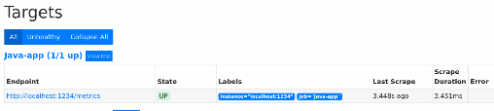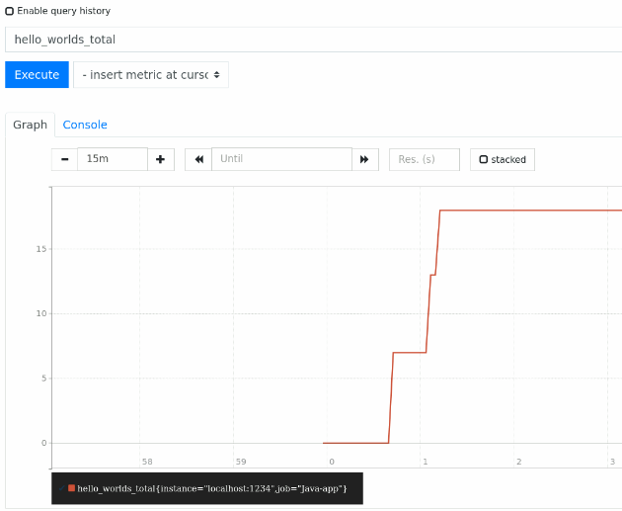

NodeExporter
https://github.com/prometheus/node_exporter

Download and run node-exporter on target host:
wget https://github.com/prometheus/node_exporter/releases/download/v1.9.1/node_exporter-1.9.1.linux-amd64.tar.gz
tar xvfz node_exporter-*.*-amd64.tar.gz
cd node_exporter-*.*-amd64
./node_exporter

Above instructions are for amd64 machines only.
For lab machines, which run on aarch64, follow below commands:
wget http://mirror.archlinuxarm.org/aarch64/extra/prometheus-node-exporter-1.9.1-2-aarch64.pkg.tar.xz
tar -xJvf prometheus-node-exporter-1.9.1-2-aarch64.pkg.tar.xz
./usr/bin/prometheus-node-exporter

Add the target in Prometheus configuration
- job_name: "My_Node_Exporter"
scrape_interval: 5s
static_configs:
- targets: ["ec2-54-144-18-215.compute-1.amazonaws.com:9100"]

Restart Prometheus service
sudo service prometheus restart

promQL to retrieve the metric
Use this query to get metrics on Prometheus: node_filesystem_size_bytes

cAdvisor
https://github.com/google/cadvisor

Install docker on localhost (if not installed already in lab)
Refer: https://docs.docker.com/engine/install/ubuntu/#install-using-the-repository
# Add Docker's official GPG key:
sudo apt-get update
sudo apt-get install ca-certificates curl
sudo install -m 0755 -d /etc/apt/keyrings
sudo curl -fsSL https://download.docker.com/linux/ubuntu/gpg -o /etc/apt/keyrings/docker.asc
sudo chmod a+r /etc/apt/keyrings/docker.asc

# Add the repository to Apt sources:
echo \
"deb [arch=$(dpkg --print-architecture) signed-by=/etc/apt/keyrings/docker.asc] https://download.docker.com/linux/ubuntu \
$(. /etc/os-release && echo "${UBUNTU_CODENAME:-$VERSION_CODENAME}") stable" | \
sudo tee /etc/apt/sources.list.d/docker.list > /dev/null
sudo apt-get update

sudo apt-get install docker-ce docker-ce-cli containerd.io docker-buildx-plugin docker-compose-plugin

Run a few containers
sudo docker run -d nginx
sudo docker run -d tomcat
sudo docker run -d httpd

Run cAdvisor container
This will expose container information as metrics on port 8080 of the target host.
export VERSION=v0.49.1

sudo docker run --volume=/:/rootfs:ro --volume=/var/run:/var/run:ro --volume=/sys:/sys:ro --volume=/var/lib/docker/:/var/lib/docker:ro --volume=/dev/disk/:/dev/disk:ro --publish=8080:8080 --detach=true --name=cadvisor --privileged --device=/dev/kmsg gcr.io/cadvisor/cadvisor:$VERSION

NOTE: If you encounter the below error, please stop Jenkins service and run the cadvisor container again (you may need to delete the existing container that was created in the previous attempt)
Error: docker: Error response from daemon: failed to set up container networking: driver failed programming external connectivity on endpoint cadvisor (48986a2b5359cf71f8c0a0a7d9cd3106eecfaf0b0fccdbfbb8fc5e8c4b34856a): failed to bind host port for 0.0.0.0:8080:172.17.0.5:8090/tcp: address already in use
- Stop Jenkins service: sudo service jenkins stop
- Remove existing container docker rm -f cadvisor
- Start cadvisor container again

Add target in Prometheus
- Add the target in /etc/prometheus/prometheus.yml file
- job_name: 'cAdvisor'
static_configs:
- targets: ["localhost:8080"]

Restart Prometheus
sudo service prometheus restart

Explore below query in Prometheus
container_cpu_system_seconds_total{name!=""}
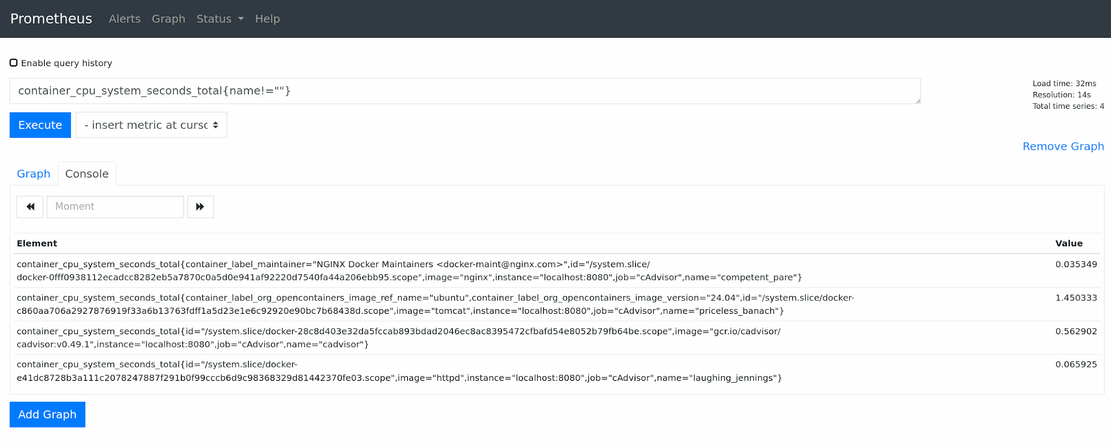

Recording Rules

Create Recording Rule
Create a rule file /etc/prometheus/record_rule.yml and add below rules
groups:
- name: "memory rules"
rules:
- expr: (node_memory_MemTotal_bytes - node_memory_MemFree_bytes)/1000/1000/1000
record: myrule_node_memory_MemUsed_gb
- record: myrule_node_memory_MemFreePercent
expr: 100 * node_memory_MemFree_bytes / node_memory_MemTotal_bytes

Include Recording Rule file in Prometheus yml
include the rule file in /etc/prometheus/prometheus.yml
# prometheus.yml
rule_files:
# - "first_rules.yml"
# - "second_rules.yml"
- "record_rule.yml"

Restart Prometheus

Check for the metric in the graph
Please wait a few seconds for the next scraping to finish, and for the metric to be available
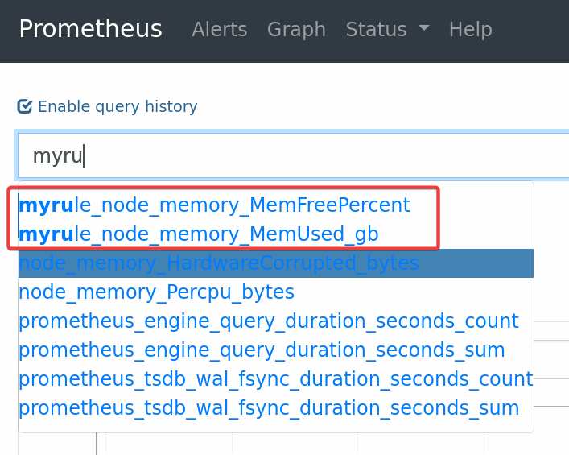

Alertmanager

Create alert rules
/etc/prometheus/alert_rule.yml
groups:
- name: java-app-alerts
rules:
- alert: JavaAppDown
expr: up{instance="localhost:1234",job="Java-app"} == 0
for: 1m
labels:
severity: critical
annotations:
summary: Java App is down. TAKE ACTION!!

Enable alert manager and import alert rules
# Alertmanager configuration
alerting:
alertmanagers:
- static_configs:
- targets:
- localhost:9093

# Load rules once and periodically evaluate them according to the global 'evaluation_interval'.
rule_files:
# - "first_rules.yml"
# - "second_rules.yml"
- "record_rule.yml"
- "alert_rule.yml"

Restart Prometheus

Start the java custom app

Trigger and view alert
After a min, stop the app by pressing ctrl-C
Check for alerts created in Prometheus
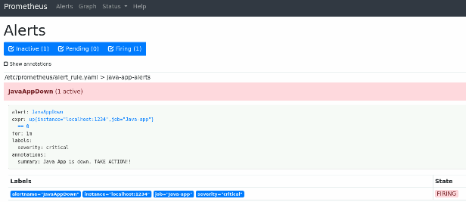

Check for same alert in Alertmananger
http://localhost:9093
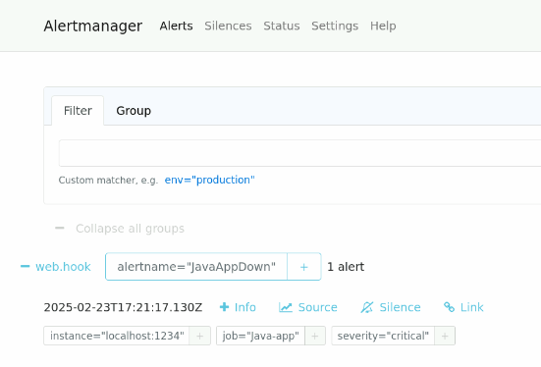

PushGateway

Create a script
Create a script called ~/my_cron_job_task.sh
This script would generate and push metrics to the PushGateway

#!/bin/bash

DB_READ_TIME_TAKEN=$RANDOM

DB_ROWS_PROCESSED=$RANDOM

METRIC_NAME_TIME="my_script_db_read_time_taken"
METRIC_NAME_ROWS="my_script_db_rows_processed"

PUSHGATEWAY_URL="http://localhost:9091"

cat <<EOF| curl --data-binary @- "$PUSHGATEWAY_URL/metrics/job/my_db_script"
# HELP $METRIC_NAME_TIME time taken to read the DB
# TYPE $METRIC_NAME_TIME gauge
$METRIC_NAME_TIME $DB_READ_TIME_TAKEN
EOF

cat <<EOF| curl --data-binary @- "$PUSHGATEWAY_URL/metrics/job/my_db_script"
# HELP $METRIC_NAME_ROWS Rows read from the DB
# TYPE $METRIC_NAME_ROWS gauge
$METRIC_NAME_ROWS $DB_ROWS_PROCESSED
EOF

Make the script executable
chmod 777 ~/my_cron_job_task.sh

Execute the script
Execute it multiple times with a gap of 15s

Validate metrics
Metrics should be visible in PushGateway http://localhost:9091
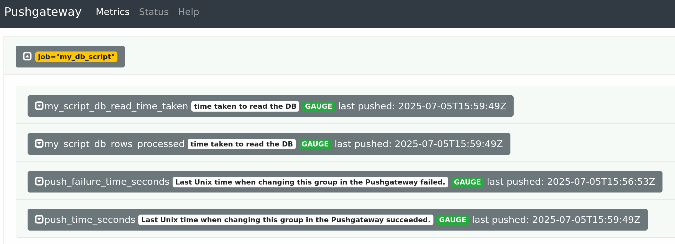

http://localhost:9091/metrics
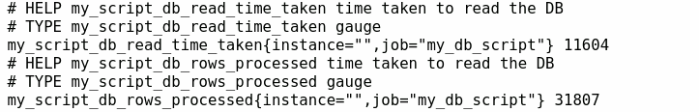

Check metrics in Prometheus
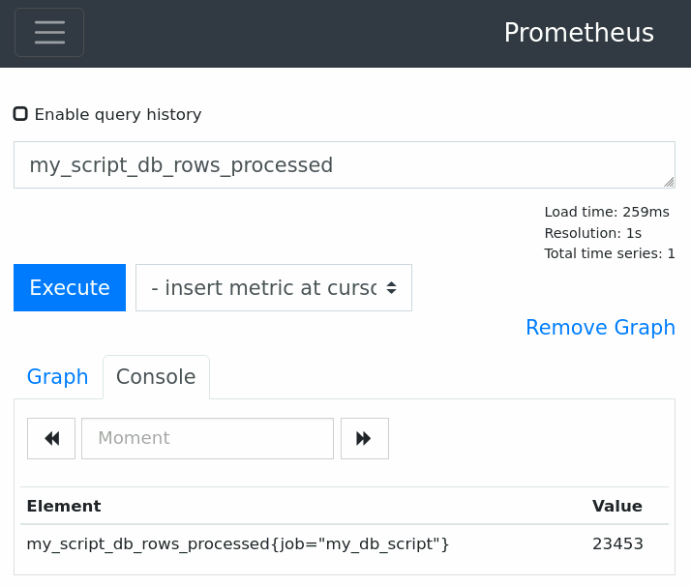

Grafana

Connect Grafana to Prometheus
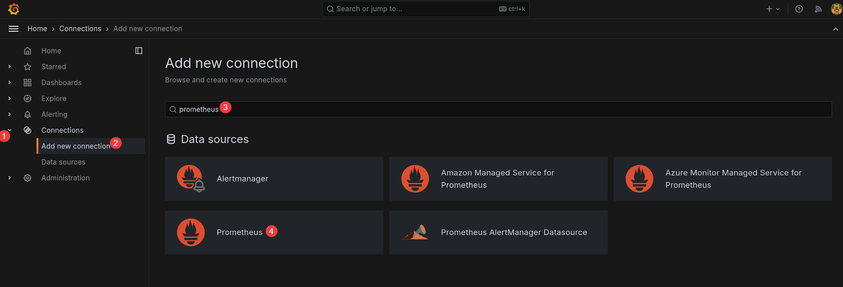

Provide Prometheus url
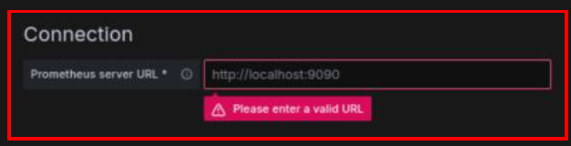
http://localhost:9090

Save
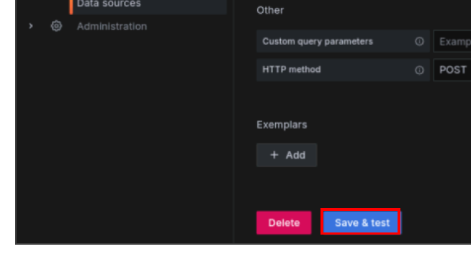

Create Dashboard from Prometheus

Create new visualization
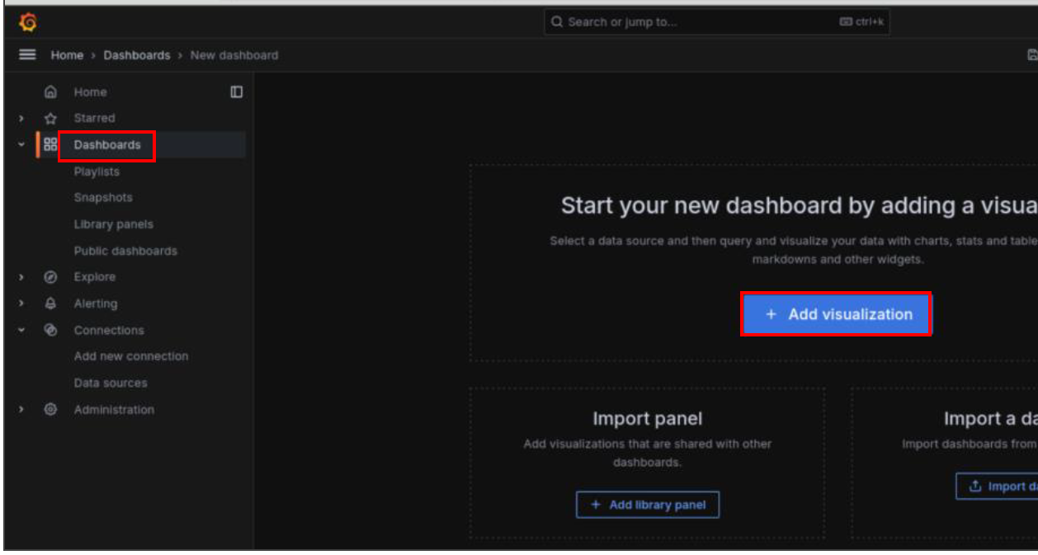

Select Prometheus Datasource
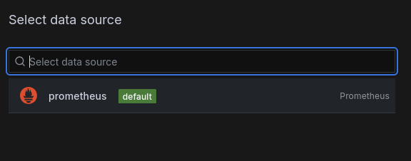

Create panel
Metric : node_memory_MemFree_bytes
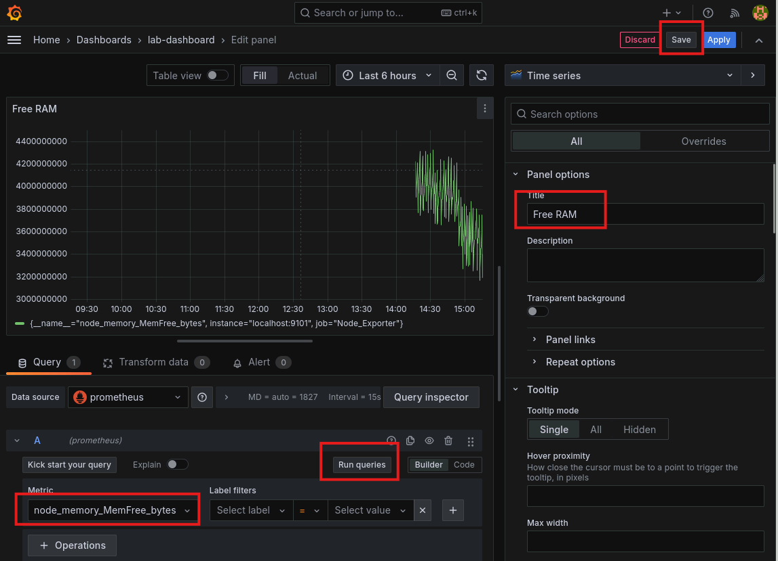

Bonus Exercise: Import
Import the “Node Exporter Full” Dashboard
https://grafana.com/grafana/dashboards/1860-node-exporter-full/

Logging
Work with ElasticSearch

Elasticsearch

Push log document to ElasticSearch
Connect with elasticsearch
curl localhost:9200

Create Index
curl -X PUT "localhost:9200/my-index"

Check the created index
curl 'localhost:9200/_cat/indices/my-index'
curl localhost:9200/my-index?pretty
curl localhost:9200/my-index/_settings?pretty

Upload Document/log to the index
curl -X POST "localhost:9200/my-index/_doc/1" -H 'Content-Type: application/json' -d'
{
"name": "amit",
"age": 10
}'

View the uploaded Doc
curl "localhost:9200/my-index/_doc/1"

Logstash

Create logstash config file
Create this file with below content: ~/logstash.conf

input {
# nginx log file
file {
path => "/var/log/nginx/access.log"
type => "nginx"
start_position => "beginning"
sincedb_path => "/dev/null"
}
}
output {
# elasticsearch
elasticsearch {
hosts => ["http://localhost:9200"]
index => "nginx"
data_stream => false
}
stdout { codec => rubydebug }
}

Run logstash
sudo /usr/share/logstash/bin/logstash -f ~/logstash.conf

Check out the new created nginx index
http://localhost:9200/_cat/indices?v
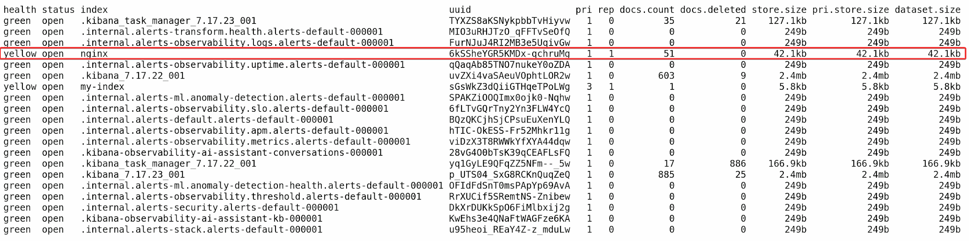

List all documents pushed to the index
http://localhost:9200/nginx/_search

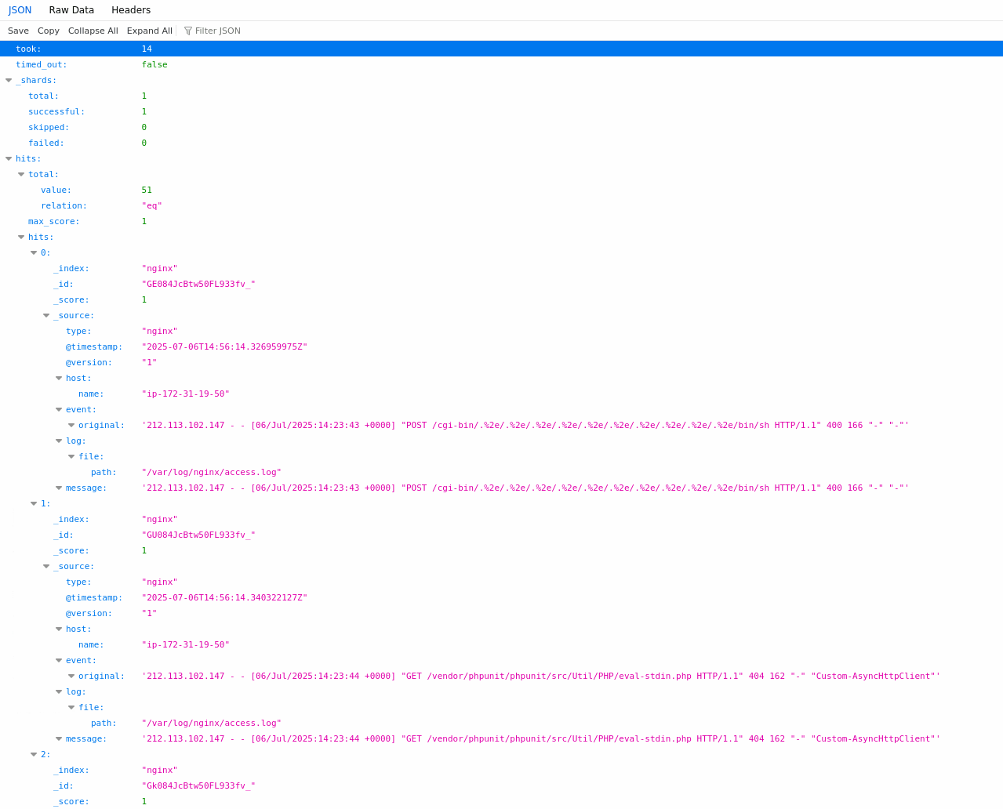

Kibana

Visualize Logs with Kibana

Open Kibana
Kibana URL : http://localhost:5601

Choose “Explore on my own”


Browse to Stack Management
Explore the indices by navigating to Home -> Stack management -> Index Management
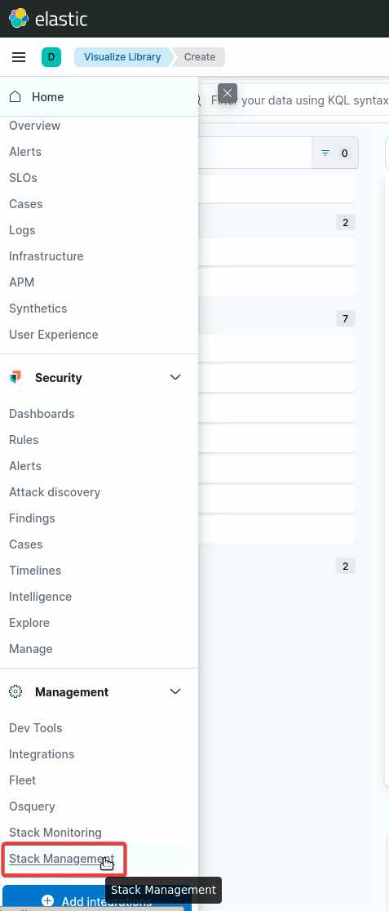
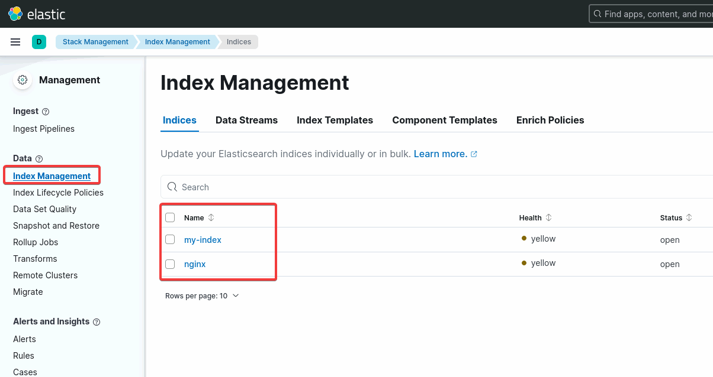

Create Data View
Home -> Analytics -> discover
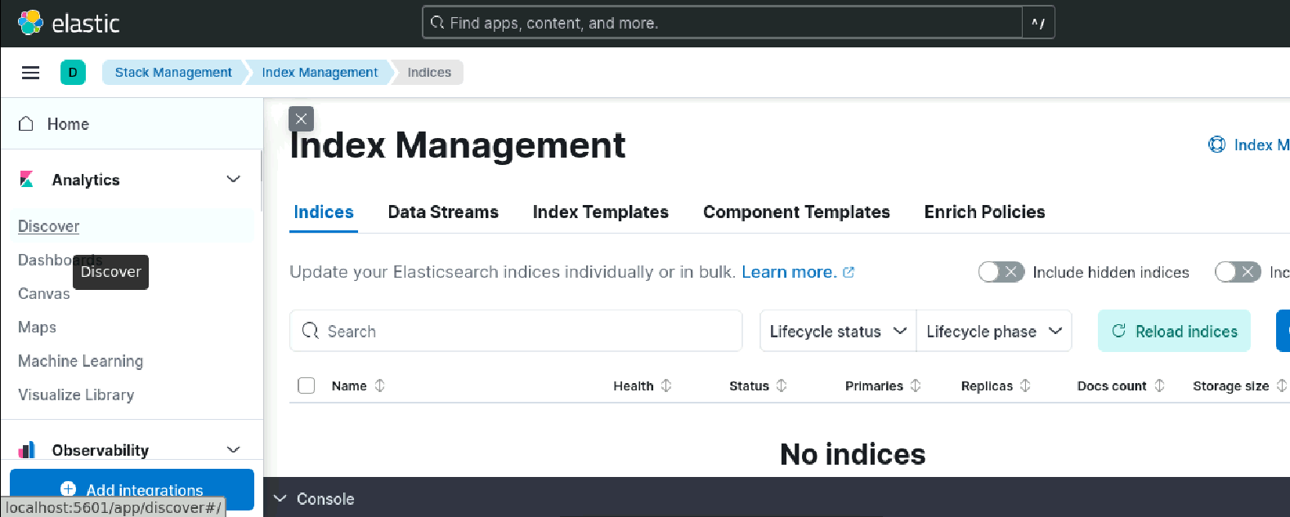
Create Data View

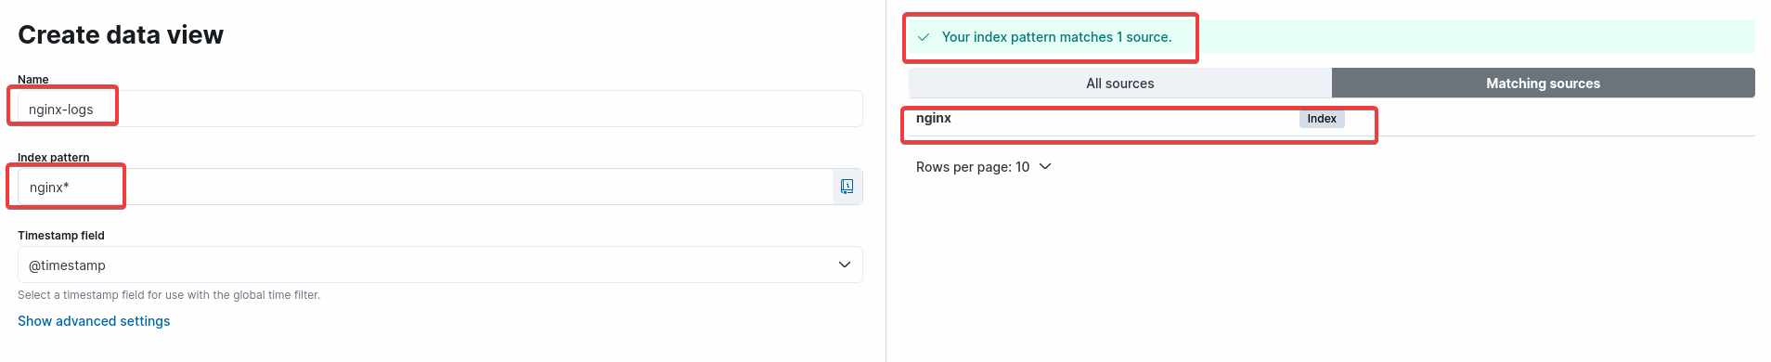

Browse the Log Documents
You may have to choose a longer time frame to see all records
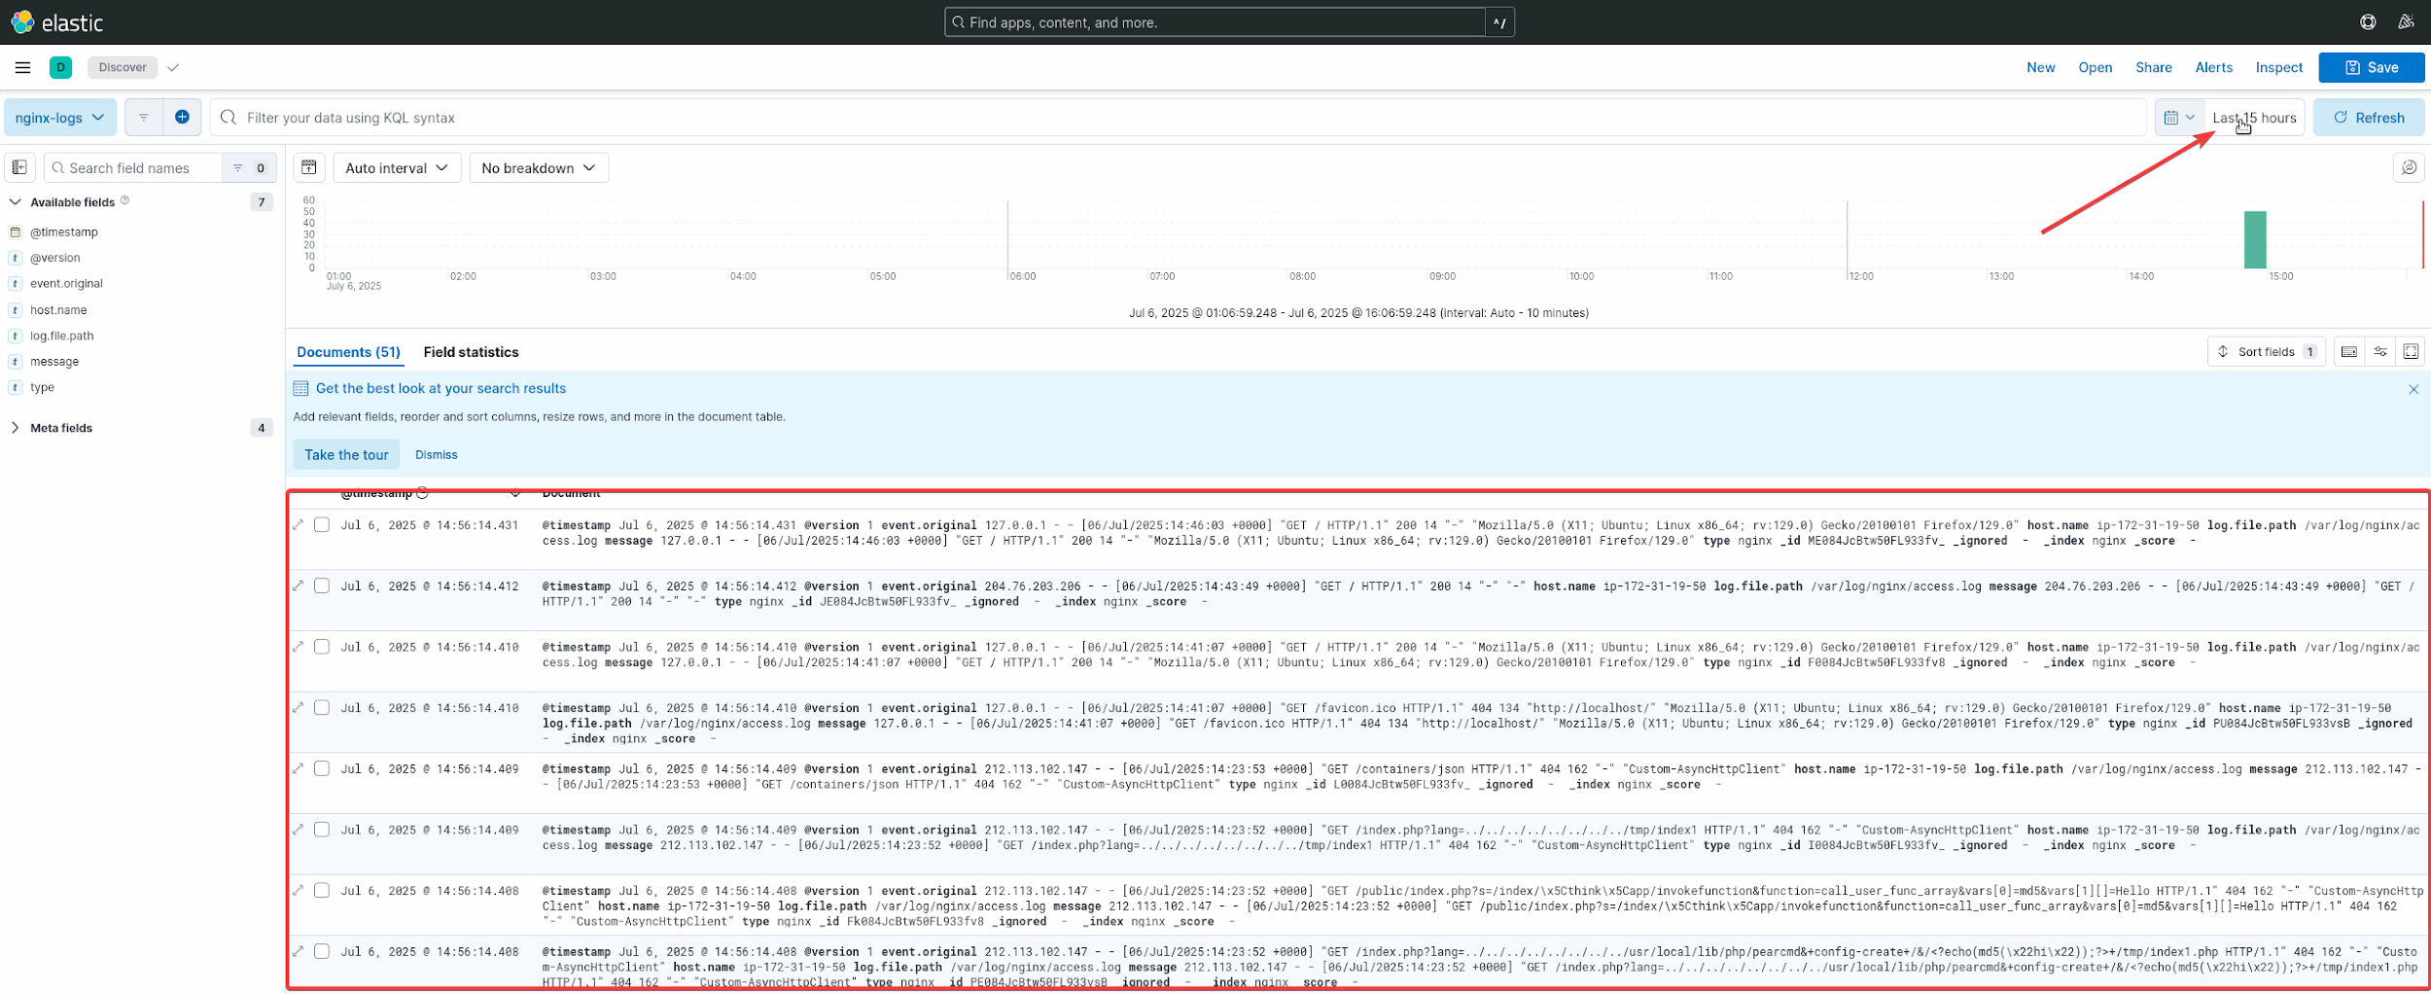

Create Dashboard
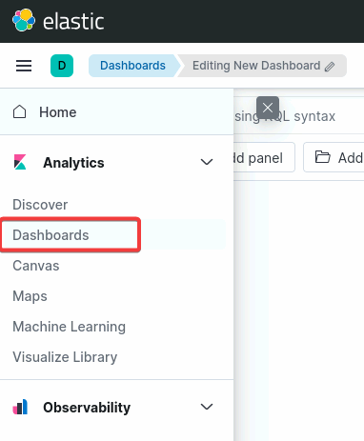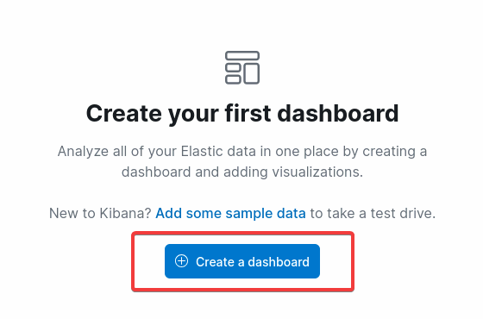

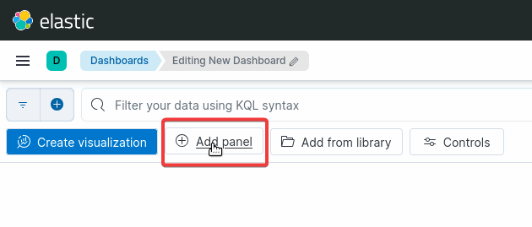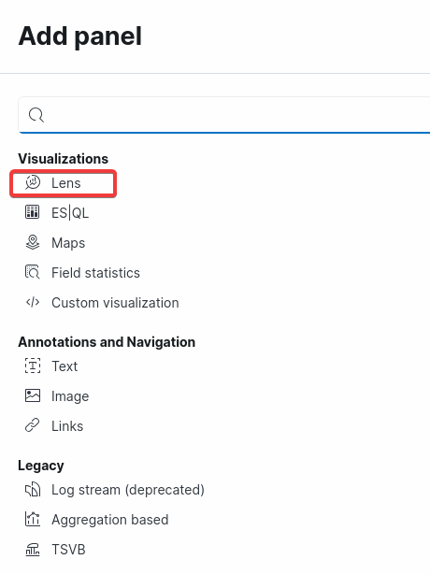

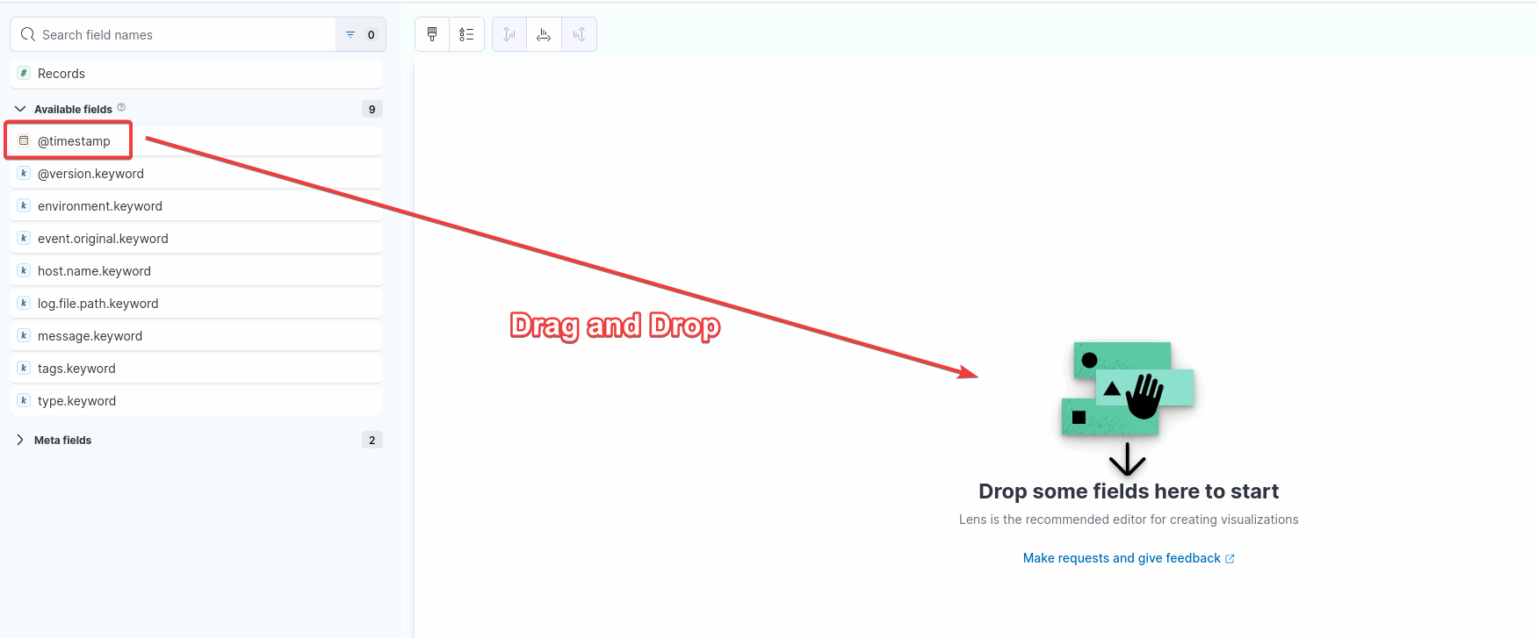
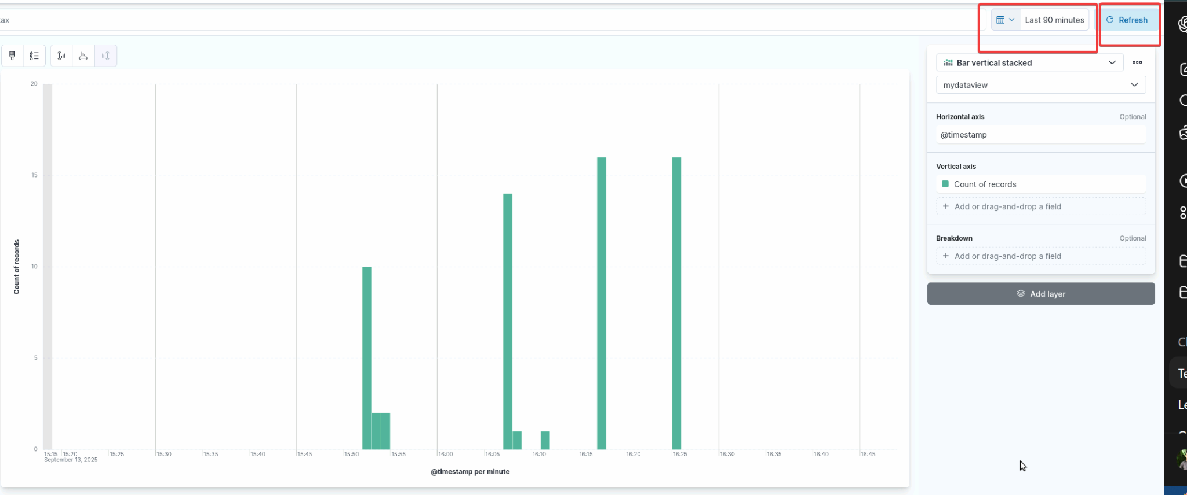

BONUS: Monitor kubernetes cluster with Prometheus

Create EKS cluster

login to AWS lab

Ensure that Region is set to us-east-1

Open cloudshell

Install eksctl
curl -sLO "https://github.com/eksctl-io/eksctl/releases/latest/download/eksctl_$(uname -s)_amd64.tar.gz"
tar -xzf eksctl_$(uname -s)_amd64.tar.gz -C /tmp
sudo mv /tmp/eksctl /usr/local/bin
eksctl version

Create cluster configuration file
~/cluster.yaml
apiVersion: eksctl.io/v1alpha5
kind: ClusterConfig
metadata:
name: my-eks-cluster # Cluster name
region: us-east-1 # Change to your preferred region
version: "1.30" # EKS version
nodeGroups:
- name: ng-1
instanceType: t3.medium # EC2 instance type
desiredCapacity: 2 # 2 worker nodes
minSize: 2
maxSize: 3

Note: Sometimes, the formatting is incorrect while pasting in vim. Set vim to “paste” mode by following the below steps

- Enter Command Mode: Ensure you are in Vim's command mode by pressing the Esc key.
- Enable Paste Mode: Type :set paste and press Enter.
- Enter Insert Mode: Press i to enter insert mode.
- Paste Text: Paste your content

Create cluster
eksctl create cluster -f ~/cluster.yaml

Wait for cluster creation to complete.
Cluster creation is completed when you see similar output as below.
2025-09-14 14:04:34 [✔] saved kubeconfig as "/home/cloudshell-user/.kube/config"
2025-09-14 14:04:34 [ℹ] no tasks
2025-09-14 14:04:34 [✔] all EKS cluster resources for "my-eks-cluster" have been created
2025-09-14 14:04:34 [ℹ] nodegroup "ng-1" has 0 node(s)
2025-09-14 14:04:34 [ℹ] waiting for at least 2 node(s) to become ready in "ng-1"
2025-09-14 14:04:51 [ℹ] nodegroup "ng-1" has 2 node(s)
2025-09-14 14:04:51 [ℹ] node "ip-192-168-23-131.ec2.internal" is ready
2025-09-14 14:04:51 [ℹ] node "ip-192-168-47-138.ec2.internal" is ready
2025-09-14 14:04:51 [✔] created 1 nodegroup(s) in cluster "my-eks-cluster"
2025-09-14 14:04:52 [ℹ] kubectl command should work with "/home/cloudshell-user/.kube/config", try 'kubectl get nodes'
2025-09-14 14:04:52 [✔] EKS cluster "my-eks-cluster" in "us-east-1" region is ready

Check Cluster accessibility
kubectl get nodes
expected output
NAME STATUS ROLES AGE VERSION
ip-192-168-23-131.ec2.internal Ready <none> 30m v1.30.14-eks-3abbec1
ip-192-168-47-138.ec2.internal Ready <none> 30m v1.30.14-eks-3abbec1

Install Prometheus stack on the cluster

Install Helm
curl -fsSL -o get_helm.sh https://raw.githubusercontent.com/helm/helm/main/scripts/get-helm-3
chmod 700 get_helm.sh
./get_helm.sh

Install Prometheus stack on the cluster
helm repo add prometheus-community https://prometheus-community.github.io/helm-charts
helm repo update
helm install kube-prometheus-stack prometheus-community/kube-prometheus-stack

Check all prometheus components
kubectl get all
Expected Output
NAME READY STATUS RESTARTS AGE
pod/alertmanager-kube-prometheus-stack-alertmanager-0 2/2 Running 0 13m
pod/kube-prometheus-stack-grafana-f7847c965-8drkh 3/3 Running 0 13m
pod/kube-prometheus-stack-kube-state-metrics-58c48d8945-cdb8c 1/1 Running 0 13m
pod/kube-prometheus-stack-operator-7985c57b5b-ldvbz 1/1 Running 0 13m
pod/kube-prometheus-stack-prometheus-node-exporter-hdc69 1/1 Running 0 13m
pod/kube-prometheus-stack-prometheus-node-exporter-kfpzm 1/1 Running 0 13m
pod/prometheus-kube-prometheus-stack-prometheus-0 2/2 Running 0 13m
NAME TYPE CLUSTER-IP EXTERNAL-IP PORT(S) AGE
service/alertmanager-operated ClusterIP None <none> 9093/TCP,9094/TCP,9094/UDP 13m
service/kube-prometheus-stack-alertmanager ClusterIP 10.100.104.188 <none> 9093/TCP,8080/TCP 13m
service/kube-prometheus-stack-grafana ClusterIP 10.100.162.65 80:30654/TCP 13m
service/kube-prometheus-stack-kube-state-metrics ClusterIP 10.100.207.221 <none> 8080/TCP 13m
service/kube-prometheus-stack-operator ClusterIP 10.100.187.175 <none> 443/TCP 13m
service/kube-prometheus-stack-prometheus ClusterIP 10.100.132.242 <none> 9090/TCP,8080/TCP 13m
service/kube-prometheus-stack-prometheus-node-exporter ClusterIP 10.100.207.162 <none> 9100/TCP 13m
service/kubernetes ClusterIP 10.100.0.1 <none> 443/TCP 41m
service/prometheus-operated ClusterIP None <none> 9090/TCP 13m
NAME DESIRED CURRENT READY UP-TO-DATE AVAILABLE NODE SELECTOR AGE
daemonset.apps/kube-prometheus-stack-prometheus-node-exporter 2 2 2 2 2 kubernetes.io/os=linux 13m
NAME READY UP-TO-DATE AVAILABLE AGE
deployment.apps/kube-prometheus-stack-grafana 1/1 1 1 13m
deployment.apps/kube-prometheus-stack-kube-state-metrics 1/1 1 1 13m
deployment.apps/kube-prometheus-stack-operator 1/1 1 1 13m
NAME DESIRED CURRENT READY AGE
replicaset.apps/kube-prometheus-stack-grafana-f7847c965 1 1 1 13m
replicaset.apps/kube-prometheus-stack-kube-state-metrics-58c48d8945 1 1 1 13m
replicaset.apps/kube-prometheus-stack-operator-7985c57b5b 1 1 1 13m
NAME READY AGE
statefulset.apps/alertmanager-kube-prometheus-stack-alertmanager 1/1 13m
statefulset.apps/prometheus-kube-prometheus-stack-prometheus 1/1 13m

Expose Grafana service on a AWS LoadBalancer
kubectl patch svc kube-prometheus-stack-grafana -p '{"spec": {"type": "LoadBalancer"}}'

Get the loadbalancer URL for the grafana service
kubectl get svc kube-prometheus-stack-grafana -o jsonpath='{.status.loadBalancer.ingress[0].hostname}'
expected output
a7bb839b0b8c346dc9192295655a8f9a-420931479.us-east-1.elb.amazonaws.com

Access Grafna
Note: LoadBalancer URL could take a few minutes to respond properly
Open the url in your laptop’s browser to access grafana
username = admin
password = prom-operator

Open various dashboards to look around

CourseEndProject

Deploy the test application

Create project dir
mkdir ~/course-end-project
cd ~/course-end-project/

Clone the java application
git clone https://github.com/simplilearn10/SpringBootPrometheusGrafana.git

cd ~/course-end-project/SpringBootPrometheusGrafana/

fix the dependency
add the highlighted line in the pom.xml
<dependency>
<groupId>org.projectlombok</groupId>
<artifactId>lombok</artifactId>
<version>1.18.30</version>
<optional>true</optional>
</dependency>

Compile and run the java application
mvn package
java -jar target/spring-boot-metrics-0.0.1-SNAPSHOT.jar

Open another terminal tab/window

Test the application
curl "localhost:8089/api/test"
expected output
Test(base)

Add Prometheus target to scrape the app
sudo vim /etc/prometheus/prometheus.yml
Add below config.
Ensure that the indentation is taken care of.
Ignore existing config contents.
- job_name: course-end-project-app
metrics_path: /actuator/prometheus
static_configs:
- targets:
- localhost:8089

Restart prometheus
sudo service prometheus restart

Validate the configuration
you should be able to see the below metric in prometheus:

books_service_books_in_store_count

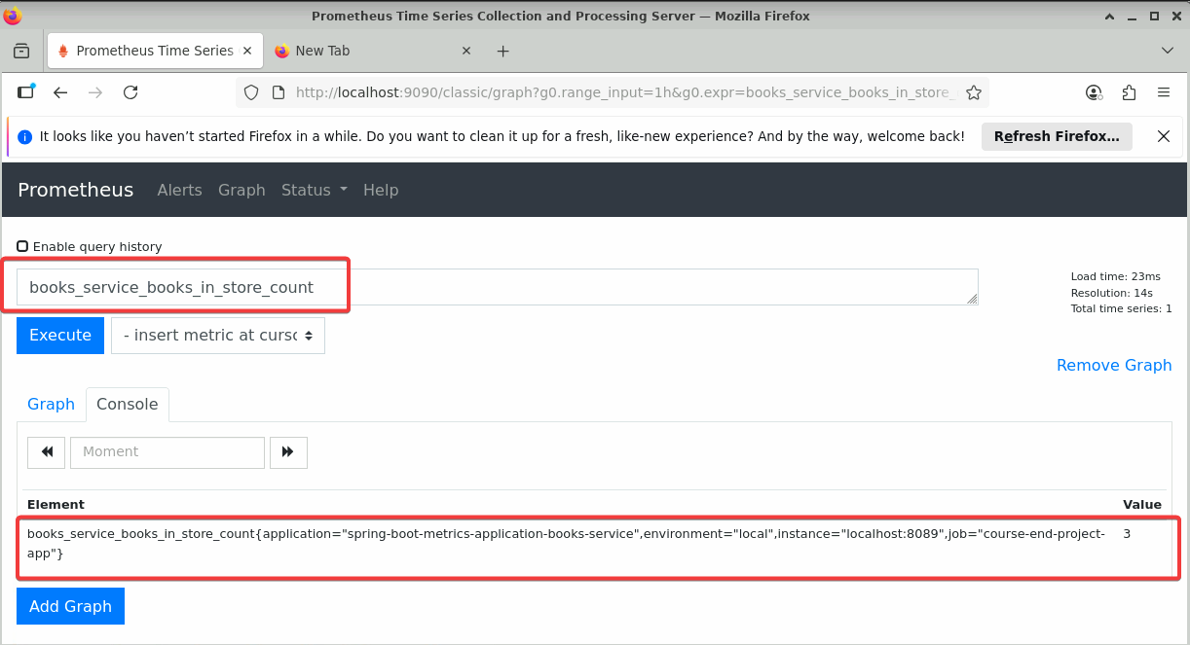

Simulate network traffic to java application
Open a new terminal

Run below commands to get ‘hey’ tool
cd ~/course-end-project
git clone https://github.com/rakyll/hey.git
cd ~/course-end-project/hey
go build

generate load
~/course-end-project/hey/hey -c 10 -n 50 "http://localhost:8089/api/test"
~/course-end-project/hey/hey -c 10 -n 20 "http://localhost:8089/api/books"
~/course-end-project/hey/hey -c 2 -n 15 "http://localhost:8089/api/books?title=Clean%20code"
~/course-end-project/hey/hey -c 10 -n 50 "http://localhost:8089/api/books?title=Fundamental%20Algorithms"
~/course-end-project/hey/hey -c 10 -n 50 "http://localhost:8089/api/books?title=Domain%20Driven%20Design"

Grafana: add visualisation

Add visualization panels for each of the below metrics:
- books_service_books_in_store_count
- books_service_books_search_by_title_seconds_sum
- books_service_api_books_get_count_total

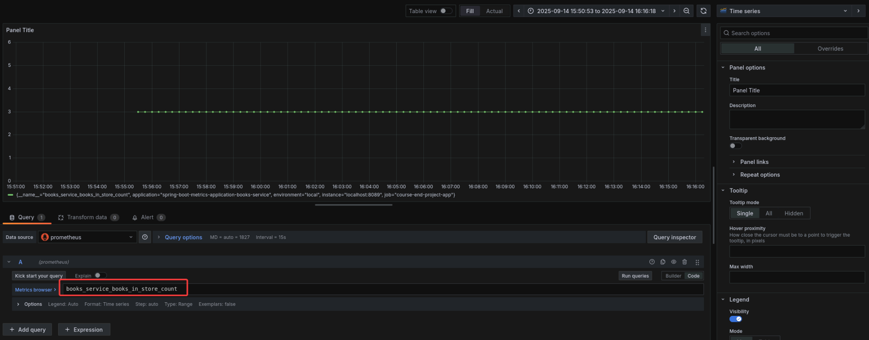
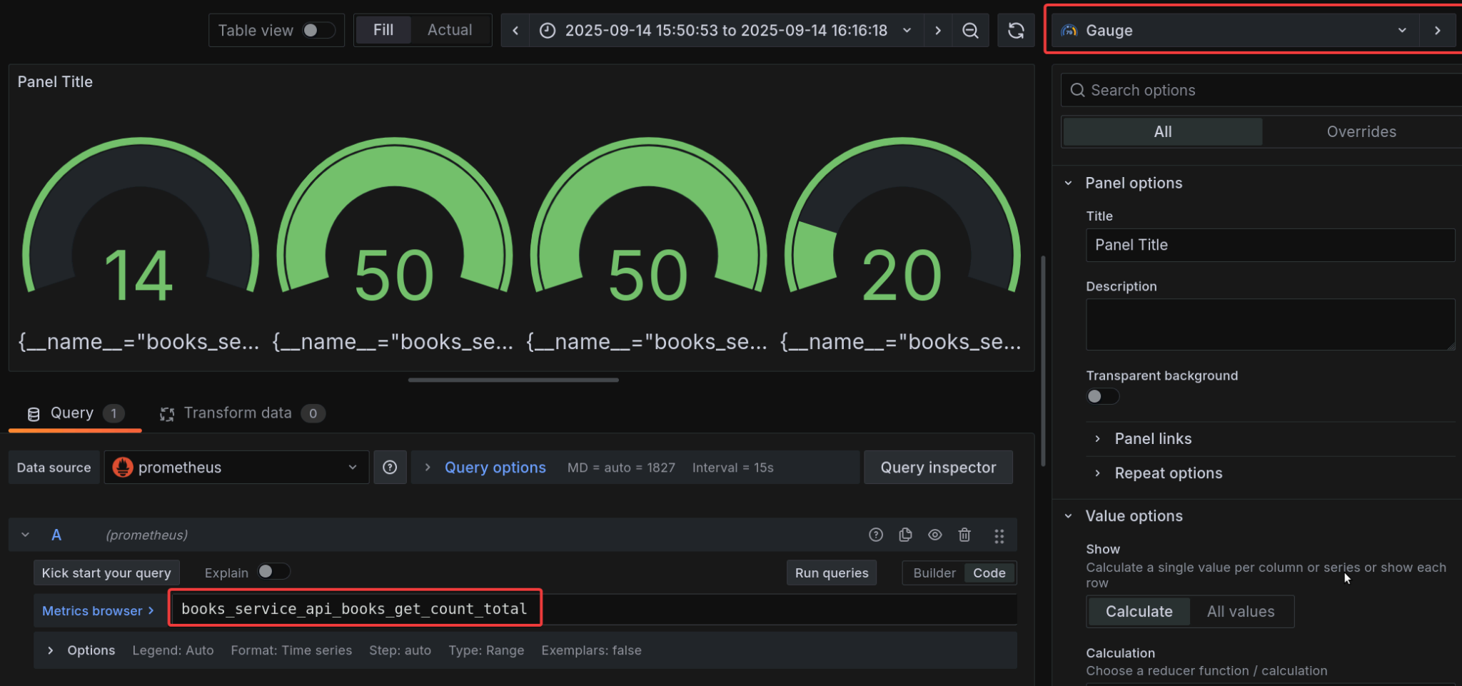
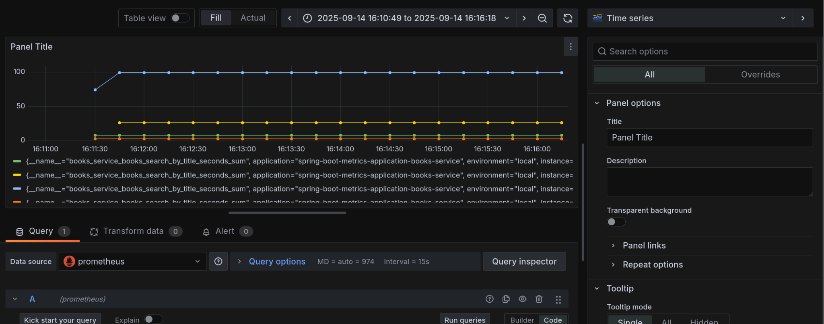

Final Dashboard:
